Applications. Web Applications and Databases
- Limitations of SQL
- SQL is declarative, intuitive, versatile, but …
SQL是声明性的，直观的，通用的，但是…
- cannot express all possible queries in SQL
- need to enforce business rules beyond domain/referential integrity
- need procedural constructs such as loops and decisions
需要过程构造，如循环和决策
- would you give end users a query browser? Why not?
- need a user interface that is both friendly and constraining
- How to handle business logic?
- Examples of business logic:
- Check name and password. If good, login, if bad, error message
- Insert one row in Order table, then several in OrderItem table
- Check amount < balance. If so, subtract amount from one row in bank account table, then add amount to another row
- For all rows in Customer table, send out monthly statements
- Procedural programming languages can do:
- Sequence (several steps performed in order)
- Iteration (loops)
- Control flow (conditionals, decisions)
- User interface (accept input and present output for users)
- Example business logic
- Customer places an order
- Accept inputs from user (e.g. via web form)
- Insert row into Order table
- Repeat for each product ordered:
- Check Product table shows sufficient quantity in stock. If so:
- Insert one row into OrderItem table
向OrderItem表中插入一行
- Change Product table in stock, Customer table amount owing更改库存产品表，客户表欠款金额
- If no errors encountered, end successfully
- Customer moves money from savings to credit card account
- Accept inputs from user (via ATM, internet banking or mobile app)
- Select balance from savings account
- Is there enough money to withdraw? If so:
- Update savings account balance = balance withdrawal
- Update credit card balance = balance + withdrawal
- If no errors encountered, end successfully
- Application Architectures应用体系结构
- System architecture
- An information system must provide
- Presentation logic表示逻辑
- input (keyboard, touchscreen, voice, sensor etc.)
- output (large screen, printer, phone, ATM etc.)
- Business logic
- input and command handling输入和命令处理
- enforcement of business rules业务规则的强制执行
- Storage logic
- persistent storage of data数据的持久存储
- enforcement of data integrity强制执行数据完整性
- 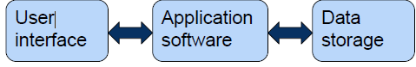
- Multi-tiered architectures
- 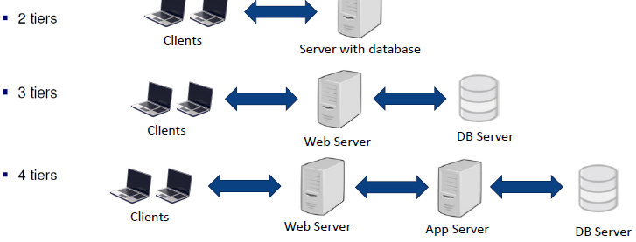
- Evolution of application architectures
- Mainframe / dumb terminal主机/哑终端
- One large computer handles all logic
- Problems: doesn’t scale with number of users问题:不随用户数量而变化
- Client-Server architecture
- 2 tier: e.g. file server, database, web
- 3 tier: separation of Presentation, Processing and Storage logic
- Web architecture
- a particular form of 3 or 4 tier architecture3或4层架构的特殊形式
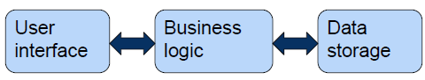
- Mainframe (“1Tier”)
- Mainframes and mini-computers
- Dumb terminals (no processing at client end) 哑终端(客户端不处理)
- Entire application ran on the same computer
整个应用程序在同一台计算机上运行
- Database
- Business logic
- User interface
- Enabling technologies included:
- Embedded SQL
- Report generators报告生成器
- Client Server-2 Tier
- Server is a relational DBMS
- data storage and access is done at the DBMS
数据的存储和访问是在DBMS中完成的
- SQL queries sent to DB server, which returns raw data
- Presentation, business logic is handled in client application
- Platforms like Visual Basic (1990s into 2000s)
- Distribution of Processing Logic处理逻辑分布
- 2-tier distributions
- Processing logic could be at client, server, or both
- 2-Tier advantages and disadvantages
- Advantages
- Clients and server share processing load客户机和服务器共享处理负载
- Good data integrity since data is all processed centrally
良好的数据完整性，因为数据都是集中处理的
- Stored procedures allow some business rules to be implemented on the database server存储过程允许在数据库服务器上实现一些业务规则
- Disadvantages
- Presentation, data model, business logic are intertwined at client
在客户端，表示、数据模型、业务逻辑相互交织
- If DB schema changes, all clients break
如果数据库模式改变，所有客户端都会崩溃
- Updates need to be deployed to all clients更新需要部署到所有客户端
- DB connection for every client, thus difficult to scale
每个客户端的DB连接，因此难以扩展
- Difficult to implement beyond the organization (to customers)
很难在组织之外(对客户)实施
- Interoperability issues互操作性问题
- 3-Tier architecture
- Client program <--> Application server <--> Database server
- Presentation logic
- Client handles interface
- Thinner clients
- Limited or no data storage (possibly no hard disk)
有限或没有数据存储(可能没有硬盘)
- Business logic
- Application Server deals with business logic
Application Server处理业务逻辑
- Storage logic
- Database server deals with data persistence and access
数据库服务器处理数据的持久化和访问
- Advantages
- Scalability 可扩展性
- Technological flexibility (can change business logic easily)
技术灵活性(可以轻松更改业务逻辑)
- Can swap out any single component fairly easily
可以很容易地换出任何单个组件吗
- Long term cost reduction
- Improved security customer machine does presentation only
改进的安全性客户机器只做演示
- Disadvantages
- High short-term costs
- Tools and training
- Complex to design
- Variable standards
- 3-Tier (web based)
- Browser handles presentation logic浏览器处理表示逻辑
- Browser talks to web server via simple, standard protocol
浏览器通过简单的标准协议与web服务器对话
- Business logic and data storage handled on server(s)
在服务器上处理的业务逻辑和数据存储
- Pros
- Everyone has a browser
- No need for install and maintain client software
- HTML and HTTP are simple standards, widely supported
- Opens up the possibility of global access to database
- Cons
- Even more complexity in the middle tier中间层更复杂
- Simple standards = hard to make complex application
- Global access = potential security nightmare (next page)
- Security in multi-tier applications多层应用程序中的安全性
- Network environment creates complex security issues
网络环境带来了复杂的安全问题
- Security can be enforced at different tiers:
- application password security
- for allowing access to the application software
- database-level password security
- for determining access privileges to tables
用于确定对表的访问权限
- secure client/server communication
- via encryption通过加密
- Web Applications
- Architecture of a web app
- 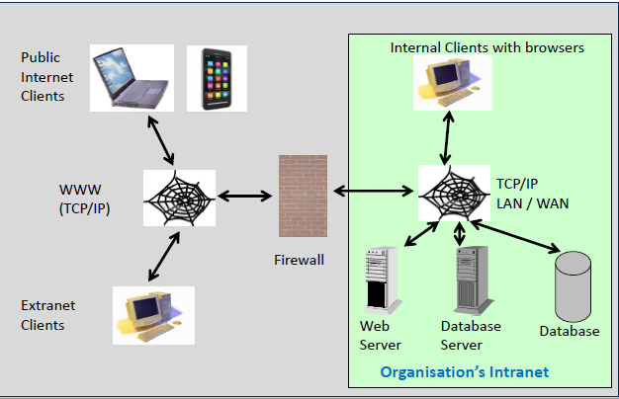
- Why create web applications?
- Web browsers are ubiquitous Web浏览器无处不在
- No need to install client software for external customers
无需为外部客户安装客户端软件
- Simple communication protocols简单的通信协议
- Platform and Operating System independent ("interoperable")
平台和操作系统独立(“可互操作”)
- Reduction in development time and cost减少开发时间和成本
- Has enabled eGov , eBusiness , eCommerce , B2B, B2C
是否启用了电子政务、电子商务、电子商务、B2B、B2C
- 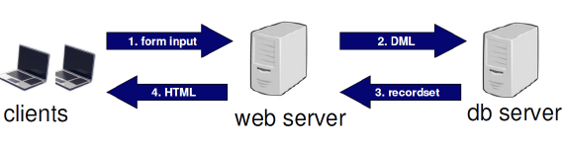
- Web infrastructure
- Browser
- Software that retrieves and displays HTML documents
检索和显示HTML文档的软件
- Web Server
- Software that responds to requests from browsers by transmitting HTML and other documents to browsers
通过向浏览器传送HTML和其他文档来响应浏览器请求的软件
- Web pages (HTML documents)
- Static web pages静态网页
- content established at development time在开发时建立的内容
- Dynamic web pages
- content dynamically generated using data from database
- World Wide Web (WWW)
- The total set of interlinked hypertext documents residing on Web servers worldwide
驻留在世界各地的Web服务器上的一组相互链接的超文本文档
- Internet
- Global network infrastructure that hosts the WWW
- Web-related languages
- Hypertext Markup Language (HTML)
- Markup language used to define a web page (content and structure) 用于定义网页(内容和结构)的标记语言。
- Cascading Style Sheets (CSS)
- Control appearance of an HTML document
- JavaScript (JS)
- Scripting language that enable interactivity in HTML documents
使HTML文档具有交互性的脚本语言
- Extensible Markup Language (XML)
- Markup language used to transport data between web services
- Build your webpages using the correct tools
- 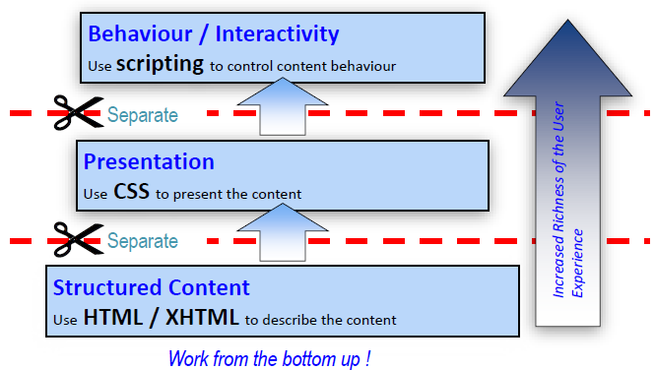
- Web page = HTML document
- A structured file of elements defined by HTML tags
由HTML标记定义的元素组成的结构化文件
- Interpreted by web browser for display通过web浏览器解释显示
- 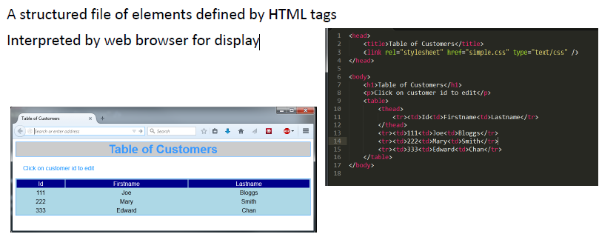
- HTML Document-Structure Tree View
- The “root” element of any html document, is the html element, which usually contains only two children head and body
- The head then contains the title, and other ‘head’ elements
head然后包含标题和其他“head”元素
- The body can contain many other elements
- 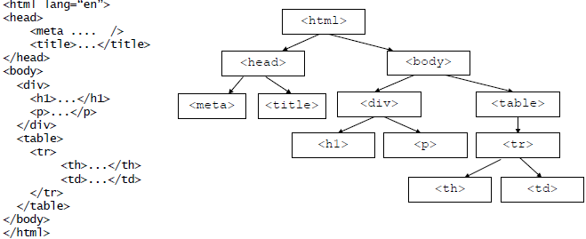
- Web Browsers display basic web page
- The <h1> is a heading element
- there are six heading sizes ranging from <h1> to <h6>
- <h6> is the smallest
- The <p> is a paragraph element
- A browser inserts empty lines before each paragraph
浏览器在每个段落前插入空行
- 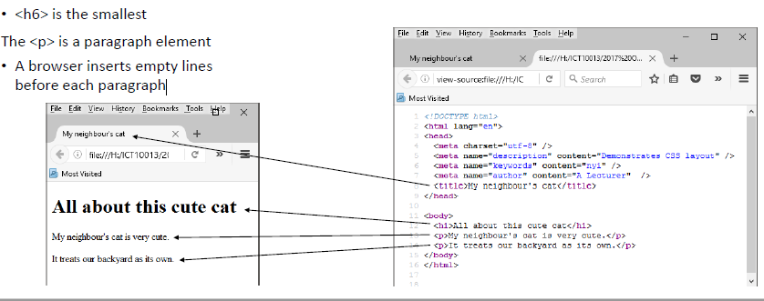
- Lists
- Ordered list example
- 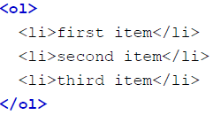
- Unordered list example
- 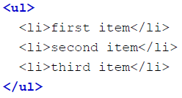
- 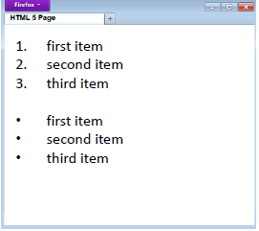
- Table
- 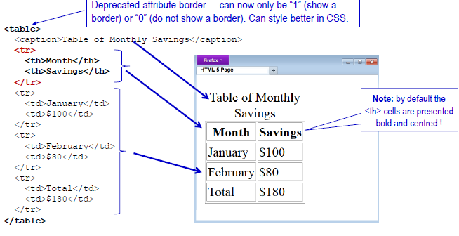
- Form element
- <form> … </form> provides a mechanism to allow a user to enter information into a web page.
<form>…</form>提供了一种允许用户输入信息到web页面的机制。
- Entered information can be submitted to a server, which it turn can receive the data, process the data and generate a response.
输入的信息可以提交给服务器，服务器可以接收数据、处理数据并生成响应。
- Possible responses may include:
- display information on a web page; 在网页上显示信息
- adding data to a database; or
- sending an email message.
- 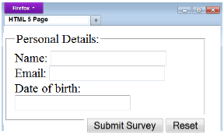
- Web Server Features
- A Web server is made up of several components:
- A computer with an Internet connection and operating system
- The server program usually runs continuously
- Web server software to receive and respond to HTTP requests.
- Handles multiple requests
- Information: a collection of documents to be
- Careful access control to server content should be a feature
对服务器内容的仔细访问控制应该是一个特性
- 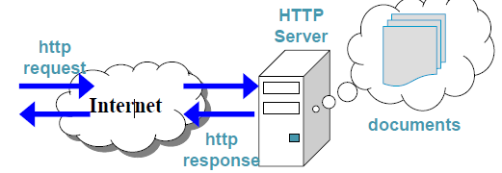
- Static vs Dynamic web pages
- STATIC web page
- the URL identifies a file on the server's file system
URL标识服务器文件系统上的一个文件
- server fetches the file and sends it to the browser
服务器获取文件并将其发送给浏览器
- the file contains HTML
- browser interprets the HTML for display on screen
浏览器解释HTML显示在屏幕上
- DYNAMIC web page
- URL identifies a program to be run
- web app runs the program
- program typically retrieves data from database
程序通常从数据库检索数据
- elements such as TABLE, LIST are populated with data
- web app uses LOOPS to fill the contents of TABLEs and LISTs.
- e.g. SELECT * FROM Product; (returns a set of product entities)
- FOR p IN ProductList , print a row in HTML table
- Problems with old style web apps
- Placing “raw” SQL inside PHP/HTML files
- Mixes presentation, business, database logic
- Hard to maintain when things change当事情改变的时候很难维持
- Want separation of concerns, e.g. MVC (model view controller)
想要分离关注点，例如MVC(模型视图控制器)
- Lots of reinvention of wheels
- each developer writes their own solution to common features
每个开发人员都为通用特性编写自己的解决方案
- e.g. login security, presentation templates, database access
- Increasing variety of clients e.g. phones and tablets
- Manually program for different platforms
- => web application frameworks
- examples: Ruby on Rails, .Net , Symfony, AngularJS, Django
- Web Services
- The WWW allows humans to access remote databases
- Web Services allow computers to access remote databases
- 2 major approaches: SOAP and REST
- Simple Object Access Protocol简单对象存取协议
- Representational State Transfer表述性状态转移
- Structured data usually returned in XML or JSON format
- REST nouns are resources, addressed via URIs
- REST verbs correspond to DML statements
- GET (select), POST (insert), PUT (update), DELETE (delete)
- XML and JSON data formats
- used by web services for data exchange
- XML
- eXensible Markup Language
- JSON
- JavaScript Object Notation

Transactions and Concurrency事务和并行
- Transactions
- Business Transactions
- Example “business transactions”:
- Placing order: Insert one row in Order table, then several in OrderItem table下订单:在order表中插入一行，然后在OrderItem表中插入几行
- Withdrawal: Check amount < balance. If so, subtract amount from one row in bank account table, then add amount to another row
提款:支票金额<余额。如果是，从银行账户表的一行减去金额，然后添加到另一行
- Sending monthly statements: For all rows in Customer table, generate and send out monthly statements
发送月结单:对于客户表中的所有行，生成并发送月结单
- Each requires several distinct database operations
- Example: move money from savings account to credit card account
- Accept inputs from user (via ATM, internet banking or mobile app)
- Select balance from savings account
- Is there enough money to withdraw? If so:
- Update savings account balance = balance – withdrawal
- Update credit card balance = balance + withdrawal
- If no errors encountered, end successfully
- Normalised Relations and ER Diagram
- We can name the relations now
- Customer (CustomerNumber, CustomerName, CustomerAddress)
- Clerk (ClerkNumber, ClerkName)
- Product (ProductNumber, ProductDescription)
- Invoice (InvoiceNumber, Date, CustomerNumber, ClerkNumber)
- InvoiceLineItem (InvoiceNumber, ProductNumber, UniPrice, Quantity)
- 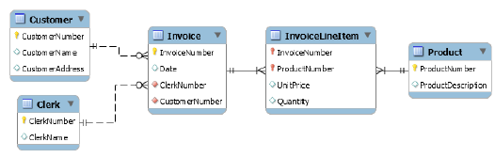
- What is a (database) Transaction?
- A logical unit of work that must either be entirely completed or aborted (indivisible, atomic)
必须完全完成或中止的逻辑工作单元(不可分割的、原子的)。
- DML statements are already atomic in MySQL*, SQL Server*
- RDBMS also allows for user-defined transactions
RDBMS还允许用户定义的事务
- These are a sequence of DML statements, such as
- a series of UPDATE statements to change values
一系列用来改变值的UPDATE语句
- a series of INSERT statements to add rows to tables
一系列INSERT语句，用于向表中添加行
- DELETE statements to remove rows DELETE语句删除行
- Transactions will be treated as atomic
- A successful transaction changes the database from one consistent state to another
成功的事务将数据库从一个一致的状态更改为另一个一致的状态
- All data integrity constraints are satisfied满足所有数据完整性约束
- Why do we need Transactions?
- Transactions solve TWO problems:
- users need the ability to define a unit of work
用户需要定义工作单元的能力
- concurrent access to data by >1 user or program
>1用户或程序并发访问数据
- Problem 1: Unit of work
- Single DML or DDL command (implicit transaction)
- Example: update 700 records, but database crashes after 200 records processed
- Restart server: you will find no changes to any records
重启服务器:您将发现任何记录都没有更改
- Changes are “all or none”
- Multiple statements (user-defined transaction) 多个语句(用户定义的事务)
- START TRANSACTION; (or, ‘BEGIN’)
- SQL statement;
- SQL statement;
- SQL statement
- COMMIT; (commits the whole transaction)
- Or ROLLBACK (to undo everything)
- SQL keywords: BEGIN; START TRANSACTION; COMMIT, ROLLBACK
- Business transactions as units of work
- Each transaction consists of several SQL statements, embedded within a larger application program
每个事务由几个SQL语句组成，嵌入到一个更大的应用程序中
- Transaction needs to be an indivisible unit of work
事务需要是一个不可分割的工作单元
- “Indivisible” means that either the whole job gets done, or none gets done:
- if an error occurs, we don’t leave the database with the job half done, in an inconsistent state
如果发生错误，我们不会让数据库工作完成一半，处于不一致的状态
- In the case of an error:
- Any SQL statements already completed must be reversed
任何已经完成的SQL语句都必须反转
- Show an error message to the user
- When ready, the user can try the transaction again
- This is briefly annoying – but inconsistent data is disastrous
- Transaction Properties (ACID) 事务属性
- Atomicity单元性
- A transaction is treated as a single, indivisible, logical unit of work. All operations in a transaction must be completed; if not, then the transaction is aborted
事务被视为单个的、不可分割的、逻辑的工作单元。事务中的所有操作都必须完成;如果不是，则事务被中止
- Consistency
- Constraints that hold before a transaction must also hold after it
在事务之前存在的约束也必须在事务之后存在
- (multiple users accessing the same data see the same value)
- Isolation
- Changes made during execution of a transaction cannot be seen by other transactions until this one is completed
在事务执行期间所做的更改无法被其他事务看到，直到该更改完成
- Durability持久性
- When a transaction is complete, the changes made to the database are permanent, even if the system fails
事务完成后，即使系统出现故障，对数据库所做的更改也是永久的
- Concurrency并发性
- Problem 2: Concurrent access问题2:并发访问
- What happens if we have multiple users accessing the database at the same time如果有多个用户同时访问数据库，会发生什么呢
- Concurrent execution of DML against a shared database
对共享数据库并发执行DML
- Note that the sharing of data among multiple users is where much of the benefit of databases derives – users communicate and collaborate via shared data
请注意，在多个用户之间共享数据是数据库的主要好处所在——用户通过共享数据进行通信和协作
- But what could go wrong?
- lost updates
- 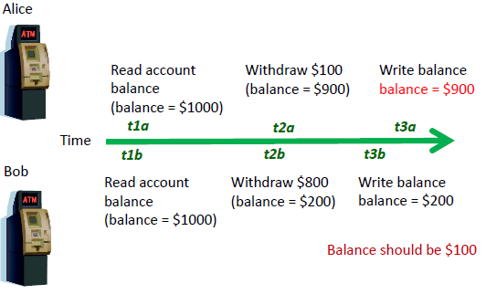
- uncommitted data未提交的数据
- Uncommitted data occurs when two transactions execute concurrently and the first is rolled back after the second has already accessed the uncommitted data
未提交数据发生在两个事务并发执行时，第一个事务在第二个事务已经访问了未提交数据后回滚
- 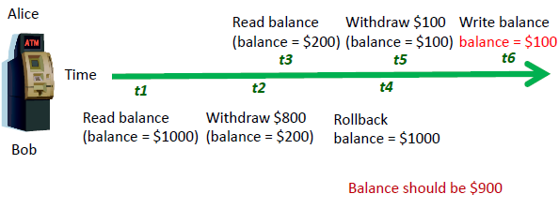
- inconsistent retrievals不一致的检索
- Occurs when one transaction calculates some aggregate functions over a set of data, while other transactions are updating the data当一个事务在一组数据上计算一些聚合函数时发生，而其他事务正在更新数据
- Some data may be read after they are changed and some before they are changed, yielding inconsistent results
有些数据可能在更改之后读取，有些则在更改之前读取，从而产生不一致的结果
- 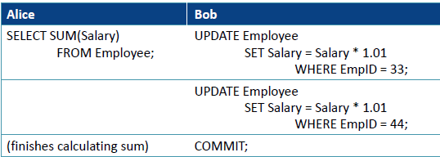
- 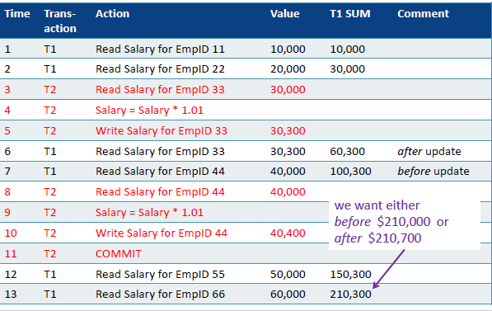
- Serializability可串行性
- Transactions ideally are “serializable” 事务在理想状态下是“可序列化的”
- Multiple, concurrent transactions appear as if they were executed one after another多个并发事务似乎是一个接一个地执行的
- Ensures that the concurrent execution of several transactions yields consistent results确保多个事务的并发执行产生一致的结果
- 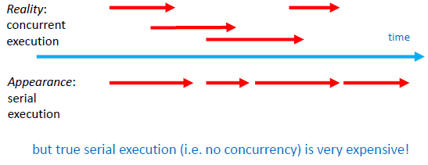
- Concurrency Control Methods
- Concurrency control methods并行控制法
- To achieve efficient execution of transactions, the DBMS creates a schedule of read and write operations for concurrent transactions
为了实现事务的高效执行，DBMS为并发事务创建一个读和写操作的时间表
- Interleaves the execution of operations, based on concurrency control algorithms such as locking and time stamping
基于锁和时间戳等并发控制算法，交叉执行操作
- Several methods of concurrency control
- Locking is the main method used锁定是使用的主要方法
- Time Stamping时间标记
- Optimistic Methods
- Concurrency Control with Locking
- Lock
- Guarantees exclusive use of a data item to a current transaction
保证数据项对当前事务的独占使用
- T1 acquires a lock prior to data access; the lock is released when the transaction is complete
T1在访问数据之前获得一个锁;当事务完成时，锁被释放
- T2 does not have access to data item currently being used by T1
T2没有访问T1当前使用的数据项
- T2 has to wait until T1 releases the lock
- Required to prevent another transaction from reading inconsistent data需要防止另一个事务读取不一致的数据
- Lock manager
- Responsible for assigning and policing the locks used by the transactions负责分配和监督事务使用的锁
- Lock Granularity: options锁的粒度:选项
- Database-level lock
- Entire database is locked整个数据库被锁定
- Good for batch processing but unsuitable for multi-user DBMSs
适合于批处理，但不适用于多用户dbms
- T1 and T2 can not access the same database concurrently even if they use different tables
T1和T2不能同时访问同一个数据库，即使它们使用不同的表
- (SQLite, Access)
- Table-level lock
- Entire table is locked - as above but not quite as bad
整个表都被锁住了——和上面一样，但没有那么糟糕
- T1 and T2 can not access the same database concurrently as long as they use different tables
T1和T2可以同时访问同一个数据库，只要它们使用不同的表
- Can cause bottlenecks, even if transactions want to access different parts of the table and would not interfere with each other
即使事务想要访问表的不同部分，并且不会相互干扰，是否会导致瓶颈
- Not suitable for highly multi-user DBMSs不适合高度多用户的dbms
- Page-level lock
- An entire disk page is locked (a table can span several pages and each page can contain several rows of one or more tables)
整个磁盘页被锁定(一个表可以跨越几个页，每个页可以包含一个或多个表的几行)
- Not commonly used now
- Row-level lock
- Allows concurrent transactions to access different rows of the same table, even if the rows are located on the same page
允许并发事务访问同一表的不同行，即使这些行位于同一页上
- Improves data availability but with high overhead (each row has a lock that must be read and written to)
提高数据可用性，但有较高的开销(每一行都有一个必须读写的锁)
- Currently the most popular approach (MySQL, Oracle)
- Field-level lock
- Allows concurrent transactions to access the same row, as long as they access different attributes within that row
允许并发事务访问同一行，只要它们访问该行中的不同属性即可
- Most flexible lock but requires an extremely high level of overhead
最灵活的锁，但需要极高的开销
- Not commonly used
- Types of Locks
- Binary Locks二元锁定
- has only two states: locked (1) or unlocked (0)
- eliminates “Lost Update” problem
- the lock is not released until the statement is completed
直到语句完成，锁才会被释放
- considered too restrictive to yield optimal concurrency, as it locks even for two READs (when no update is being done)
被认为限制太多，无法产生最佳的并发性，因为它甚至锁定了两次读取(当没有更新时)
- Exclusive and Shared locks
- often called Read and Write locks
- Writers never block Readers
- INSERT UPDATE DELETE should never block a SELECT
- Readers never block Writers
- SELECT should never block INSERT UPDATE DELETE
- Read Consistent; Read Committed are 2 options
- Exclusive lock
- Access is reserved for the transaction that locked the object
访问权限为锁定该对象的事务保留
- Must be used when transaction intends to WRITE
- Granted if and only if no other locks are held on the data item
当且仅当数据项上没有其他锁时授予
- In MySQL: “select … for update
- Shared lock
- Other transactions are also granted Read access
- Issued when a transaction wants to READ data, and no Exclusive lock is held on that data item
当一个事务想要读取数据，并且该数据项上没有独占锁时发出
- multiple transactions can each have a shared lock on the same data item if they are all just reading it
如果多个事务只是在读取同一个数据项，那么它们可以在同一个数据项上各自拥有一个共享锁
- In MySQL: “select … lock in share mode”
- Strict Two Phase Locking (Strict 2PL) 严格两相锁(严格2PL)
- Two Rules
- If a transaction T wants to read an object O, it first requests a shared lock on the object and then obtains an exclusive lock
如果一个事务T想要读取一个对象O，它首先请求该对象上的一个共享锁，然后获得一个排它锁
- All locks held by transaction T are released when the transaction is completed. 事务T持有的所有锁在事务完成时被释放。
- In effect the locking protocol only allows 'safe' interleaving of transactions Ti. 实际上，锁定协议只允许“安全”的事务交叉。
- If two transactions are accessing completely different parts of the db they concurrently obtain the locks and proceed.
- If two transactions T1 ,T2 are accessing the same object and one wants to modify it, their actions are ordered serially – all actions of one transaction T1 must complete before the other transaction T2 can proceed.
如果两个事务T1、T2正在访问同一个对象，其中一个想要修改它，那么它们的动作是按顺序排列的——一个事务T1的所有动作必须在另一个事务T2能够继续之前完成。
- Deadlock
- Condition that occurs when two transactions wait for each other to unlock data当两个事务等待对方解锁数据时发生的条件
- T1 locks data item X, then wants Y
- T2 locks data item Y, then wants X
- Each waits to get a data item which the other transaction is already holding每个事务都等待获取另一个事务已经持有的数据项
- Could wait forever if not dealt with如果不处理，能永远等下去吗
- Only happens with exclusive locks
- Deadlocks are dealt with by:
- prevention
- detection察觉
- Deadlock demo
- Two separate sessions
- In order
- Tx1 Update row 3 (Green)
- Tx2 Update row 2 (White)
- Tx3 Update row 2 (Green)
- Tx4 Update row 3 (White)
- Note: Only the session which detects the deadlock rolls back the transaction. The Green session still holds locks on row 2 and 3
注意:只有检测到死锁的会话才会回滚事务。Green会话仍然持有第2行和第3行上的锁
- Transaction Isolation Levels
- Isolation levels provide the level any given transaction is exposed to the actions of other executing transactions
隔离级别提供任何给定事务对其他执行事务的操作公开的级别
- Isolation levels are READ UNCOMMITTED, READ COMMITTED, REPEATABLE READ and SERIALIZABLE
- Serializable is the highest degree of isolation可序列化是最高级别的隔离
- Locks are obtained for both reads (R) and writes (W)
- Transaction T only reads committed transactions
事务T只读取已提交的事务
- Repeatable Read
- T1 reads the values established by the first read. This means that if you issue several SELECT statements within the same transaction (T1), these SELECT statements are consistent also with respect to each other – even if the values have been modified by other transacts (T2,T3,…Tn) until a commit is issued.
T1读取第一次读取所建立的值。这意味着，如果您在同一个事务(T1)中发出多个SELECT语句，这些SELECT语句之间也相互一致——即使这些值已经被其他事务(T2,T3，…Tn)修改，直到发出提交。
- READ COMMITTED
- Only reads committed changes by other transactions
仅读取其他事务提交的更改
- No value written by T1 is changed by another transaction until T1 completes (commits)
在T1完成之前，其他事务不会更改由T1写入的值(提交)。
- However a value read by T1 can be modified by other transactions Tn while T1 is in progress.
但是T1读取的值可以被其他事务Tn在T1运行时修改。
- Read committed holds exclusive locks (x) before writing objects and shared locks (s) before reading objects.
读提交在写对象之前持有排它锁(x)，在读对象之前持有共享锁(s)。
- READ UNCOMMITTED
- Does not obtain shared locks before reading
在读取之前没有获得共享锁
- Prohibits any transaction from making changes (i.e. write)
禁止任何事务进行更改(即写入)
- Access mode is read only
- SET TRANSACTION ISOLATION LEVEL <level>;
- Alternative concurrency control methods
- Timestamp
- Assigns a global unique timestamp to each transaction
为每个事务分配一个全局惟一的时间戳
- Each data item accessed by the transaction gets the timestamp
事务访问的每个数据项都将获得时间戳
- Thus for every data item, the DBMS knows which transaction performed the last read or write on it
因此，对于每一个数据项，DBMS知道是哪个事务对它执行了最后的读或写操作
- When a transaction wants to read or write, the DBMS compares its timestamp with the timestamps already attached to the item and decides whether to allow access
当一个事务需要读或写时，DBMS将它的时间戳与已经附加到该事务上的时间戳进行比较，并决定是否允许访问
- Optimistic乐观的
- Based on the assumption that the majority of database operations do not conflict基于此假设，大多数数据库操作不冲突
- Transaction is executed without restrictions or checking
事务的执行没有限制或检查
- Then when it is ready to commit, the DBMS checks whether any of the data it read has been altered – if so, rollback
然后当它准备提交时，DBMS检查它读取的数据中是否有任何数据被修改过——如果有，则回滚
- Logging transactions
- If transaction cannot be completed, it must be aborted and any changes rolled back如果事务无法完成，则必须中止事务并回滚任何更改
- To enable this, DBMS tracks all updates to data
- This transaction log contains:
- a record for the beginning of the transaction
- for each SQL statement
- operation being performed (update, delete, insert)
正在执行的操作(更新、删除、插入)
- objects affected by the transaction
- “before” and “after” values for updated fields
- pointers to previous and next transaction log entries
指向上一个和下一个事务日志条目的指针
- the ending (COMMIT) of the transaction
- Transaction log
- Also provides the ability to restore a corrupted database
还提供了恢复损坏的数据库的能力
- If a system failure occurs, the DBMS will examine the log for all uncommitted or incomplete transactions and it will restore the database to its previous state
如果系统发生故障，DBMS将检查所有未提交或未完成的事务的日志，并将数据库恢复到以前的状态

